Capstone Project Notes

Company’s name: Italian Logistic company
Title of the challenge: Analysis and Prediction of Business Performance
Business Challenge Specific Objectives & Expectations: Customer segmentation and profiling based on customer sectors, size, and purchasing behavior in the recent past
Business Challenges resources available for research: A dataset (dataset.csv) with purchasing behaviour for different clients of the Logistic Company in different market segments as well as ATECO file (Ateco.xls) to map clients with their economic sector
Any other aspects to consider: Italian Logistic is under a fierce competitive pressure from its competitors
Background: The Italian Logistic company needs to understand which customers to target in increase revenue. This can be determined by analysing purchasing behaviours, size etc
Challenge: You are a team of data scientists that is asked to present an analysis of current customer segmentation and build a model to forecast future monthly revenue. This will help logistic company to define a strategy to target the right customers
It will be necessary to :explain the rationales behind your recommendations, for example try to identify:
- Which sectors are the most promising for the logistic company to sell to?
- Are there regions that are outperforming others?
- What are the characteristics of high-performing (in terms of revenue for the logistic company) companies in this dataset?

Data Analysis

  - Understanding the Business Objectives
Goal: Help the Italian logistic company target the right customers to increase revenue.
Specific objectives:
- Customer segmentation & profiling
  - Identify groups of customers with similar characteristics (sector, size, purchasing behaviour).
  - Understand which types of customers contribute most to revenue.
- Revenue forecasting
  - Build a model to forecast future monthly revenue per customer or segment.
  - Use it to prioritize high-value customers and sectors.
- Insights for strategy
  - Identify high-performing sectors and regions.
  - Describe characteristics of top-revenue customers.

1.1 Dataset Overview
Code:
# 1. Load Dataset
project_root = Path(__file__).resolve().parents[1]
original_data_path = project_root / "data" / "dataset.csv"
# 2. Translate Column Heads from Italian to English
df = create_input_en_version(project_root, original_data_path)
print(f"Saved {df.shape[0]} rows and {df.shape[1]} columns")
# 3. Dataset Overview
print(df.info())
print(df.describe())
print(df.head())
Output:
Saved 20436 rows and 42 columns
<class 'pandas.DataFrame'>
RangeIndex: 20436 entries, 0 to 20435
Data columns (total 42 columns):
# Column Non-Null Count Dtype
--- ------ -------------- -----
0 ateco_code 20049 non-null str
1 ateco_desc 20049 non-null str
2 legal_nature 20436 non-null str
3 revenue 20436 non-null int64
4 employees 20436 non-null int64
5 province 16936 non-null str
6 m-35 20436 non-null int64
7 m-34 20436 non-null int64
8 m-33 20436 non-null int64
9 m-32 20436 non-null int64
10 m-31 20436 non-null int64
11 m-30 20436 non-null int64
12 m-29 20436 non-null int64
13 m-28 20436 non-null int64
14 m-27 20436 non-null int64
15 m-26 20436 non-null int64
16 m-25 20436 non-null int64
17 m-24 20436 non-null int64
18 m-23 20436 non-null int64
19 m-22 20436 non-null int64
20 m-21 20436 non-null int64
21 m-20 20436 non-null int64
22 m-19 20436 non-null int64
23 m-18 20436 non-null int64
24 m-17 20436 non-null int64
25 m-16 20436 non-null int64
26 m-15 20436 non-null int64
27 m-14 20436 non-null int64
28 m-13 20436 non-null int64
29 m-12 20436 non-null int64
30 m-11 20436 non-null int64
31 m-10 20436 non-null int64
32 m-9 20436 non-null int64
33 m-8 20436 non-null int64
34 m-7 20436 non-null int64
35 m-6 20436 non-null int64
36 m-5 20436 non-null int64
37 m-4 20436 non-null int64
38 m-3 20436 non-null int64
39 m-2 20436 non-null int64
40 m-1 20436 non-null int64
41 m-0 20436 non-null int64
dtypes: int64(38), str(4)
memory usage: 6.5 MB
None
revenue employees ... m-1 m-0
count 2.043600e+04 20436.000000 ... 20436.000000 20436.000000
mean 3.814559e+06 21.343120 ... 566.194510 614.266246
std 7.999604e+06 159.474594 ... 3882.217904 4626.793992
min 0.000000e+00 0.000000 ... 0.000000 0.000000
25% 0.000000e+00 1.000000 ... 0.000000 0.000000
50% 5.217480e+05 4.000000 ... 0.000000 0.000000
75% 3.275647e+06 15.000000 ... 98.000000 82.000000
max 5.792155e+07 19555.000000 ... 198993.000000 251130.000000

[8 rows x 38 columns]
ateco_code ... m-0
0 G.47.71.00 ... 139105
1 H.49.41.00 ... 95330
2 G.47.91.30 ... 237050
3 N.77.40.00 ... 85649
4 NaN ... 82700

[5 rows x 42 columns]

Dataset Overview:
Rows: 20,436 → fairly large dataset, manageable in pandas
Columns: 42 → 4 categorical (ateco_code, ateco_desc, legal_nature, province) + 38 numeric (revenue, employees, m-35 … m-0)
Memory usage: 6.5 MB → small, can comfortably compute aggregations

Missing values
From info():
- ateco_code & ateco_desc → 387 missing rows (~1.9%)
  - There are 20436 entries
  - 0 ateco_code 20049 non-null str
  - 1 ateco_desc 20049 non-null str
  - 20436 – 20049 = 387
- province → 4,500 missing (~22%)
  - 5 province 16936 non-null str
  - 20436 – 16936 = 4500
- Other numeric columns (revenue, employees, m-*) → no missing
Next actions:
- Decide how to handle missing province → maybe “Unknown” or drop for regional analysis
- Decide how to handle missing ateco_code/desc → maybe drop these for sector-level analysis

Basic statistics
From describe():
Metric | Revenue | Employees | M-0
mean | 3.81M | 21.34 | 614
std | 7.99M | 159.47 | 4626
min | 0 | 0 | 0
25% | 0 | 1 | 0
50% (median) | 0.52M | 4 | 0
75% | 3.28M | 15 | 82
max | 57.9M | 19,555 | 251,130

Observations:
- Revenue is highly skewed (median << mean)
- Employees also skewed → some very large companies
- Most recent months (m-0, m-1) have many zeros → some companies may not have purchased in the last month
[TODO: Explore and detail better these observations]

1.2 Clean Up Data
Actions:
- Remove rows where ateco_code, and province are empty
- Do not remove rows where ateco_desc is empty because this information is complementary, if ateco_code exists so it is enough
[TODO] The missing ateco_desc can be obtained from the other file, ATECO.xlsb, and complement the data frame
Code:
def create_sanitized_dataset(project_root, path_from: str, path_to: str) -> pd.DataFrame:
data_path_from = project_root / "data" / path_from
# Load dataset
df = pd.read_csv(
data_path_from,
sep=";",
encoding="cp1252",
decimal=",",
)
# Remove rows for info is missing
df = df.dropna(subset=['ateco_code', 'ateco_desc', ‘province’])
# Check results
print("Cleaned rows:", len(df))
print("Missing province after cleaning:", df['province'].isnull().sum())
# Optionally, save to CSV
data_path_to = project_root / "data" / path_to
df.to_csv(data_path_to, index=False, sep=";", encoding="utf-8")
return df
--
from pathlib import Path
from util.descriptive_analytics import overview_dataset
from util.io_utils import create_en_translated_file_dataset, create_sanitized_dataset
def main():
# 1. Load Original Dataset
project_root = Path(__file__).resolve().parents[1]
# 2. Translate Column Heads from Italian to English
df = create_en_translated_file_dataset(project_root, "dataset.csv", "dataset-en.csv")
# 3. Dataset Overview
overview_dataset(df)
# 4. Sanitize data
df = create_sanitized_dataset(project_root, "dataset-en.csv", "dataset-en-cleaned.csv")
# 5. Sanitized Data Overview
overview_dataset(df)

Output:
Cleaned rows: 16807
Missing province after cleaning: 0
<class 'pandas.DataFrame'>
Index: 16807 entries, 0 to 20435
Data columns (total 42 columns):
# Column Non-Null Count Dtype
--- ------ -------------- -----
0 ateco_code 16807 non-null str
1 ateco_desc 16807 non-null str
2 legal_nature 16807 non-null str
3 revenue 16807 non-null int64
4 employees 16807 non-null int64
5 province 16807 non-null str
6 m-35 16807 non-null int64
7 m-34 16807 non-null int64
8 m-33 16807 non-null int64
9 m-32 16807 non-null int64
10 m-31 16807 non-null int64
11 m-30 16807 non-null int64
12 m-29 16807 non-null int64
13 m-28 16807 non-null int64
14 m-27 16807 non-null int64
15 m-26 16807 non-null int64
16 m-25 16807 non-null int64
17 m-24 16807 non-null int64
18 m-23 16807 non-null int64
19 m-22 16807 non-null int64
20 m-21 16807 non-null int64
21 m-20 16807 non-null int64
22 m-19 16807 non-null int64
23 m-18 16807 non-null int64
24 m-17 16807 non-null int64
25 m-16 16807 non-null int64
26 m-15 16807 non-null int64
27 m-14 16807 non-null int64
28 m-13 16807 non-null int64
29 m-12 16807 non-null int64
30 m-11 16807 non-null int64
31 m-10 16807 non-null int64
32 m-9 16807 non-null int64
33 m-8 16807 non-null int64
34 m-7 16807 non-null int64
35 m-6 16807 non-null int64
36 m-5 16807 non-null int64
37 m-4 16807 non-null int64
38 m-3 16807 non-null int64
39 m-2 16807 non-null int64
40 m-1 16807 non-null int64
41 m-0 16807 non-null int64
dtypes: int64(38), str(4)
memory usage: 5.5 MB
None
revenue employees ... m-1 m-0
count 1.680700e+04 16807.000000 ... 16807.000000 16807.000000
mean 4.326521e+06 24.073065 ... 511.054739 555.777950
std 8.464529e+06 174.974654 ... 3528.414815 4244.137361
min 0.000000e+00 0.000000 ... 0.000000 0.000000
25% 8.336500e+03 1.000000 ... 0.000000 0.000000
50% 7.619780e+05 6.000000 ... 0.000000 0.000000
75% 3.978784e+06 18.000000 ... 87.000000 76.000000
max 5.792155e+07 19555.000000 ... 135577.000000 237050.000000

[8 rows x 38 columns]
ateco_code ... m-0
0 G.47.71.00 ... 139105
1 H.49.41.00 ... 95330
2 G.47.91.30 ... 237050
3 N.77.40.00 ... 85649
5 J.62.01.00 ... 76719

[5 rows x 42 columns]

1.3 Descriptive Analytics

1.3.1 Number of Companies per Sector

Code:
def number_companies_per_sector(df: pd.DataFrame):
sector_counts = (
df
.groupby(['ateco_code', 'ateco_desc'])
.size()
.reset_index(name='company_count')
.sort_values('company_count', ascending=False)
)
sector_counts['share_%'] = (
sector_counts['company_count'] / len(df) * 100
).round(2)
return sector_counts

Output:
-----------------------------------
Number of companies per sector
-----------------------------------
ateco_code company_count share_%
0 G.47.91.10 1050 6.25
1 H.53.20.00 309 1.84
2 O.8411L1 207 1.23
3 G.47.71.10 196 1.17
4 H.49.41.00 190 1.13
5 N.82.99.99 176 1.05
6 J.62.01.00 176 1.05
7 G.46.46.30 170 1.01
8 G.47.62.20 157 0.93
9 J.58.11.00 155 0.92
1.3.2 Sector Revenue Concentration

Code:
def sector_revenue_concentration(df: pd.DataFrame):
sector_revenue = (
df
.groupby('ateco_code')['revenue']
.sum()
.reset_index()
.sort_values('revenue', ascending=False)
)
sector_revenue['revenue_share_%'] = (
sector_revenue['revenue'] / sector_revenue['revenue'].sum() * 100
).round(2)
return sector_revenue

Output:
-----------------------------------
Sector Revenue Concentration
-----------------------------------
ateco_code revenue revenue_share_%
1057 O.8411L1 2935330766 4.04
516 G.45.11.01 1447544621 1.99
822 H.49.41.00 1304423573 1.79
811 G.47.91.10 1124259107 1.55
642 G.46.46.30 978003646 1.34
265 C.25.62.00 843451651 1.16
675 G.46.69.99 838776533 1.15
891 J.62.01.00 793416317 1.09
845 H.52.29.10 670948959 0.92
625 G.46.42.10 630491147 0.87

Graph:

def plot_sector_revenue_pie(df, top_n=10):
sector_revenue = (
df.groupby('ateco_code')['revenue']
.sum()
.sort_values(ascending=False)
)
top_sectors = sector_revenue.head(top_n)
others = sector_revenue.iloc[top_n:].sum()
pie_data = pd.concat([
top_sectors,
pd.Series({'Others': others})
])
base_colors = plt.cm.tab20.colors[:len(top_sectors)]
colors = list(base_colors) + ["#d9d9d9"] # soft gray for Others
plt.figure(figsize=(9, 9))
plt.pie(
pie_data,
labels=pie_data.index,
colors=colors,
autopct='%1.1f%%',
startangle=140,
wedgeprops={'edgecolor': 'white'}
)
plt.title(f"Sector Revenue Concentration (Top {top_n} + Others)")
plt.tight_layout()
plt.show()
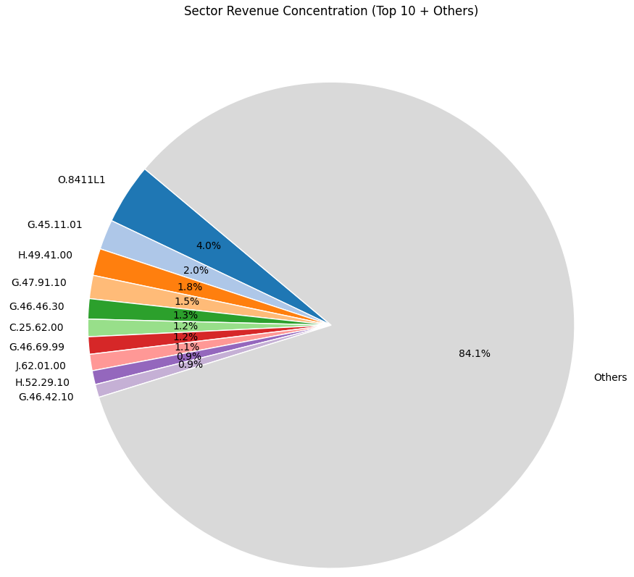

1.3.3 Pareto Performance by Sector
Pareto cumulative curve (80/20 visualization).
How many sectors generate 80% of revenue (Pareto-style).
Extract dominant sectors.
Pareto curve graph.

Code:
def sector_pareto(df: pd.DataFrame):
sector_rev = (
df.groupby("ateco_code")["revenue"]
.sum()
.sort_values(ascending=False)
.reset_index()
)
sector_rev["cum_revenue"] = sector_rev["revenue"].cumsum()
total_revenue = sector_rev["revenue"].sum()
sector_rev["cum_share"] = sector_rev["cum_revenue"] / total_revenue
return sector_rev

def sector_pareto_num(sector_rev: pd.DataFrame):
cutoff = (sector_rev["cum_share"] <= 0.8).sum()
total_sectors = len(sector_rev)
percent = cutoff / total_sectors
print(f"{cutoff} sectors generate ~80% of total revenue")
print(f"Total sectors: {total_sectors}")
print(f"Percent: {percent:.1%}")
def dominant_sectors(sector_rev: pd.DataFrame, threshold=0.80):
dominant = sector_rev[sector_rev["cum_share"] <= threshold].copy()
dominant["sector_share_%"] = (
dominant["revenue"] / sector_rev["revenue"].sum() * 100
).round(2)
dominant["cum_share_%"] = (dominant["cum_share"] * 100).round(2)
return dominant

def plot_pareto(sector_rev: pd.DataFrame):
plt.figure(figsize=(10,6))
plt.plot(sector_rev["cum_share"].values)
plt.axhline(0.8, linestyle="--") # 80% revenue line
plt.xlabel("Sectors (sorted by revenue)")
plt.ylabel("Cumulative revenue share")
plt.title("Pareto Curve — Sector Revenue Concentration")
plt.ylim(0, 1.05)
plt.show()

Output:
-----------------------------------
Pareto Performance by Sector
-----------------------------------
278 sectors generate ~80% of total revenue
Total sectors: 1173
Percent: 23.7%
ateco_code revenue cum_revenue cum_share sector_share_% cum_share_%
0 O.8411L1 2935330766 2935330766 0.040367 4.04 4.04
1 G.45.11.01 1447544621 4382875387 0.060274 1.99 6.03
2 H.49.41.00 1304423573 5687298960 0.078213 1.79 7.82
3 G.47.91.10 1124259107 6811558067 0.093674 1.55 9.37
4 G.46.46.30 978003646 7789561713 0.107123 1.34 10.71
5 C.25.62.00 843451651 8633013364 0.118723 1.16 11.87
6 G.46.69.99 838776533 9471789897 0.130258 1.15 13.03
7 J.62.01.00 793416317 10265206214 0.141169 1.09 14.12
8 H.52.29.10 670948959 10936155173 0.150396 0.92 15.04
9 G.46.42.10 630491147 11566646320 0.159066 0.87 15.91
10 G.46.90.00 623262460 12189908780 0.167638 0.86 16.76
11 G.46.74.20 618107818 12808016598 0.176138 0.85 17.61
12 G.46.74.10 609472422 13417489020 0.184519 0.84 18.45
13 C.20.42.00 578305125 13995794145 0.192472 0.80 19.25
14 C.14.10.00 546701110 14542495255 0.199991 0.75 20.00
15 G.45.31.01 517046811 15059542066 0.207101 0.71 20.71
16 C.22.29.09 512619968 15572162034 0.214151 0.70 21.42
17 C.22.20.00 502103978 16074266012 0.221056 0.69 22.11
18 C.18.12.00 491507154 16565773166 0.227815 0.68 22.78
19 C.15.20.10 466350423 17032123589 0.234229 0.64 23.42
20 C.25.99.99 456477576 17488601165 0.240506 0.63 24.05
21 J.58.14.00 453957192 17942558357 0.246749 0.62 24.67
22 G.46.43.10 432916496 18375474853 0.252703 0.60 25.27
23 G.46.49.90 425004062 18800478915 0.258547 0.58 25.85
24 O.8411L3 419484837 19219963752 0.264316 0.58 26.43
25 C.21.20.09 417542380 19637506132 0.270058 0.57 27.01
26 C.22.22.00 408239430 20045745562 0.275672 0.56 27.57
27 N.82.99.99 391762360 20437507922 0.281060 0.54 28.11
28 K.64.19.10 388364096 20825872018 0.286401 0.53 28.64
29 C.28.14.00 386197331 21212069349 0.291712 0.53 29.17
30 N.79.11.00 385650938 21597720287 0.297015 0.53 29.70
31 J.58.11.00 381383738 21979104025 0.302260 0.52 30.23
32 G.46.46.10 376313535 22355417560 0.307435 0.52 30.74
33 M.70.22.09 376179000 22731596560 0.312609 0.52 31.26
34 F.43.21.01 365759118 23097355678 0.317639 0.50 31.76
35 G.46.62.00 365319910 23462675588 0.322663 0.50 32.27
36 G.46.39.20 352026911 23814702499 0.327504 0.48 32.75
37 I.55.10.00 344439365 24159141864 0.332240 0.47 33.22
38 G.46.38.90 342773185 24501915049 0.336954 0.47 33.70
39 C.25.11.00 337877608 24839792657 0.341601 0.46 34.16
40 G.46.61.00 331663476 25171456133 0.346162 0.46 34.62
41 G.47.71.10 330018540 25501474673 0.350700 0.45 35.07
42 C.29.32.09 317605435 25819080108 0.355068 0.44 35.51
43 C.13.10.00 317556428 26136636536 0.359435 0.44 35.94
44 G.46.45.00 316779298 26453415834 0.363792 0.44 36.38
45 H.52.29.22 316276413 26769692247 0.368141 0.43 36.81
46 C.17.21.00 315362562 27085054809 0.372478 0.43 37.25
47 E.38.11.00 313365733 27398420542 0.376788 0.43 37.68
48 A.01.21.00 312945176 27711365718 0.381091 0.43 38.11
49 G.46.51.00 297976640 28009342358 0.385189 0.41 38.52

Graph:

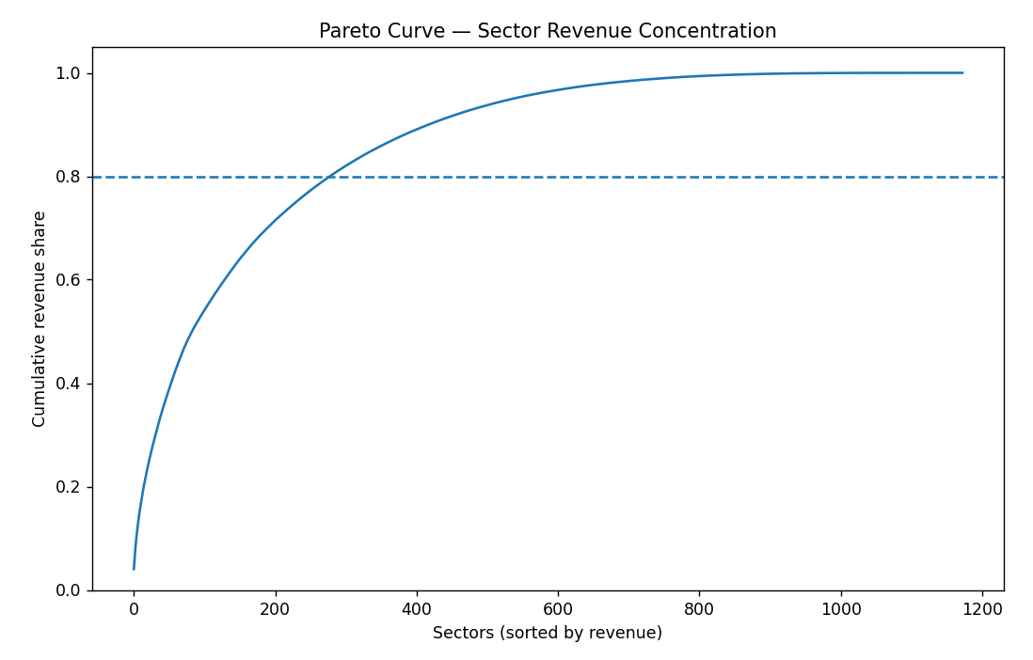
Comments:
Core revenue engines: Sectors at the top of this list.
These should be:
- Priority sales targets
- Focus for pricing strategy
- Key partnership industries

Long tail sectors: Hundreds of small low-value clients.
These usually:
- Cost more to serve than they generate
- Are poor growth investments

Behavior Intelligence

Code:
def growth_slope(row):
y = row.values
x = np.arange(len(y))
return np.polyfit(x, y, 1)[0]
def prepare_monthly_data(df: pd.DataFrame):
month_cols = sorted(month_cols, key=lambda x: int(x.split('-')[1]), reverse=True)
monthly_data = df[month_cols]
return monthly_data
def fast_growing_customers(df: pd.DataFrame, monthly_data: pd.DataFrame):
df['growth_trend'] = monthly_data.apply(growth_slope, axis=1)
# Flag top growers
df['fast_growing'] = df['growth_trend'] > df['growth_trend'].quantile(0.90)
return df[['growth_trend', 'fast_growing']].describe()

Result:
Detect Fast-Growing Customers
We use trend slope (linear regression per row)

Interpretation:
• Positive large slope → accelerating customer
• Negative slope → shrinking customer

growth_trend
count 20049.000000
mean 1.412915
std 167.289748
min -19307.416731
25% -1.113385
50% -0.043887
75% 0.442471
max 3395.405019

